GEOL 3305

Chapter 17

Moisture

CHANGES OF STATE

H2O - Solid, Liquid, Gas

Solid, liquid, and gaseous phases of water are evident in a Apollo 17 photo of Earth

Latent Heat - Heat may be added or removed without an accompanying temperature change if a change of Phase occurs.

Latent heat of Evaporation/Condensation - 600 cal/gm

Latent heat of Melting/Freezing - 80 cal/gm

Latent heat of Sublimation/Deposition - 680 cal/gm

Latent Heat - Heat may be added or removed without an accompanying temperature change if a change of phase occurs.

At the Triple point, Gas, liquid, and solid forms of water can exist.

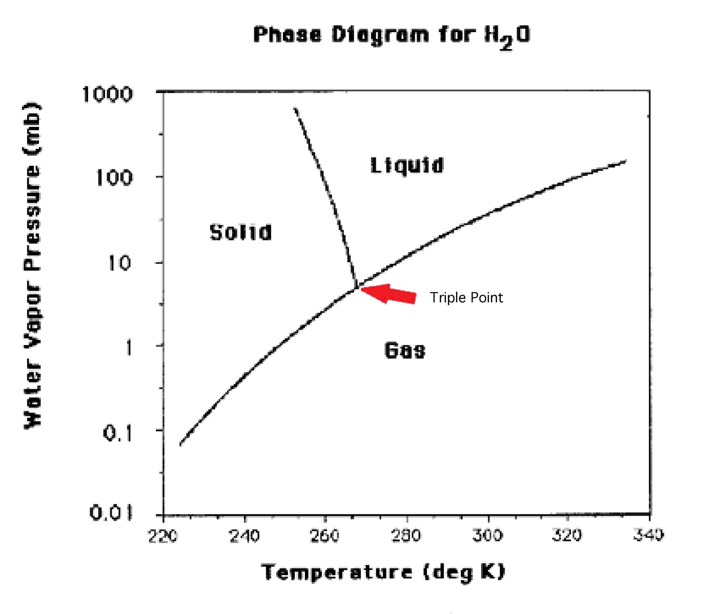

Specific heat of water - This is the heat that is stored in water.
1 calorie is required to raise the temperature of 1 gm of H2O by 1 degree C.

When you hold an ice cube in your hand it feels cold because the heat that
causes the ice to melt is coming from your hand.

Latent Heat - Heat may be added or removed without an accompanying temperature change if a change of phase occurs.

Adding heat to a beaker with ice and water doesn’t increase the temperature of the water until all the ice is melted.

When condensation occurs for an upward moving parcel of air in the atmosphere, latent heat is given off. This added heat to the parcel of air gives it more buoyancy and makes it more likely to rise further in the atmosphere.

Humidity

Water vapor pressure - that part of the total atmospheric pressure due to the water vapor molecules in the air

Saturation - The equilibrium condition between a surface of water and the volume above the surface such that the amount of evaporation from the surface and the amount of condensation into the surface are equal.

Saturation mixing ratio is the amount of water vapor required for saturation.

It changes with temperature. At high temperature it takes more water to saturate

the atmosphere.

MEASURES OF HUMIDITY

Specific Humidity - the mass of H2O contained in a chosen mass of air (gm/kg)

Relative Humidity - the ratio of the water vapor content to its capacity
-it is a function of both Specific Humidity (amount of moisture in the air) & temperature. So it is a bad way to report the humdity. Dewpoint Temperature is the best way to report the amount of humidity in the air.

Dewpoint - the temperature to which air has to be cooled to reach saturation. Using dewpoint temperature you can calculate the Specific humidity, so they are equivalent.

- When the air temperature drops close to the dewpoint temperature, latent heat is released and the temperature doesn’t get any colder. This enables you to estimate how cold the temperature is likely to get at night in the winter.

- If the dew point is 35 degrees, then the temperature will probably not get below 36 deg.

INSTRUMENTS TO MEASURE HUMIDITY

Psychrometer - wet bulb thermometer & dry bulb thermometer
which allow all 3 measures of humidity to be determined.
I used a sling psychrometer in class to measure the relative humidity in the classroom.

Hygrometer
- the length of some fibers (such as human hair) is proportional to relative humidity
- electrical conductivity of some materials is proportional to relative humidity

Rising air cools at the dry adiabatic rate (10 deg K/km) until Saturation

Absolute stability occurs when air rises (cooling at 10 deg K/km) and its temperature gets colder than the surrounding air. Then it sinks.
This occurs frequently when the Earth's surface is cold.

Absolute instability occurs when air rises at the 10 deg/km rate and its temperature is still warmer than the surrouding air. Then it continues to rise.
This almost never occurs except just above (1 inch) of a hot surface (desert). This is the cause of a mirage.

Conditional Stability occurs when air rises at 10 deg K/km and it becomes colder than surrouding air so it sinks. Except when condensation occurs and the rate changes from 10 deg K/km to a smaller number (maybe 6) and so it doesnn't cool so much and at some point becomes warmer than the surrouding air. Then continues to rise.

Conditional Stability is the most common situation on planet Earth.

When air rises and its temperature decreases enough to produce saturation and
clouds form, latent heat of condensation is released.

Adiabatic cooling of air occurs when it rises or fall and this is due to the change of atmospheric pressure. When air goes from high pressure (near the surface) to lower pressure above, the temperature of the parcel (visualize a balloon) decreases. The Opposite occurs when air at altitude sinks (it becomes warmer).

Radiosondes are used to determine the vertical structure of the atmosphere including altitude, temperature, pressure &humidity

Radiosonde from Kennedy Space Center
February 3, 1994

Pressure Temperature DewPoint Height
(mb) (deg C) (deg C) (km)

1027 6 5 0.0
935 4 1 0.8
900 6 -24 1.1
700 1 -19 3.1
631 -3 -22 4.0
560 -6 -19 5.0
480 -14 -24 6.0
422 -21 -27 7.0
375 -26 -36 8.0
270 -42 -53 10.0
120 -73 --- 15.0
79 -74 --- 18.0

Temperature Inversion (often occurs in winter)

- Temperature increases with height

- Most stable condition

- Pollution Cause

A temperature inversion canform due to cooling of the surface or from subsiding air aloft

Condensation requires

- Saturation

- Surface upon which it can occur (condensation nuclei or a car or leaf, etc)

Water drops

- Form from water molecules up to 40 micrometers in size

- Form by collision of drops at larger sizes

- Break apart at diameters larger than 5 mm

- Terminal velocity 33 km/ hr (21 miles/hr).

Bergeron process

- Ice has lower vapor pressure than water

- Once freezing starts all liquid is rapidly frozen.
Cloud Formation

- Rising air cools adiabatically (about 10 deg C/km)

Processes that Lift Air

1) Orographic Lifting - air is lifted by mountains

2) Frontal Wedging - warmer less dense air is forced over cooler, denser air.

3) Convergence - air flowing together at the surface results in upward movement & clouds.

4) Divergence at ground (makes clear skies due to the air being warmed by the increased pressure as it descends).

Divergence at ground (air flows apart and forces air above it to sink)

5) Localized Convective Lifting - unequal surface heating causes localized pockets of air to rise.

A rain shadow is created by air moving eastward over
the Sierra Nevada mountains causing rain in California and deserts in Nevada. Some of the rainest locations on the Earth occur on windward slopes of mountains. The Island of Kauai in the Hawaii Islands is the rainest location on Earth

Fog

- Radiation cooling of ground (clear nights)

- Movement of warm moist air over cold surface (Advective)

- Evaporation Fogs

- Steam (cold air over warm water)

- frontal wedging (rain evaporates & causes fog)

Forms of solid water on Earth

- Sleet - drizzle or rain that is frozen (0.5-5mm)

- Glaze - supercooled rain contacts objects

- Rime - supercooled cloud or fog contact objects (looks like feathers)

- Hail is larger than rain or sleet

Types of Clouds

Cirrus - high cold thin clouds (Wispy) "Mares Tails"

Cumulus - fluffy or billowy clouds (usually with a flat base)

Cirrocumulus - high level Cumulus

Stratus - uniform layer

Cirrostratus - high level Stratus

Nimbo - means dark (e.g. Nimbostratus is dark stratus

Nimbostratus - dark stratus

Cumulonimbus - dark thunderstorms (sometimes severe)

Bernard Cells. During almost still conditions, Bernard cells form over a warm surface. They can be open (clear center) or closed (cloudy center).

